How to get to MEPhI dormitory:
From Domodedovo airport
- Take Aeroexpress train from the airport. Exit at the stop “Verkhnie Kotly”. Schedule of Aeroexpress is available here.
- Take either 907, 275 or т71 going to MEPhI. Exit at the bus stop “MEPhI”.
- Walk to the address Moskvorechiye 2 building 1.
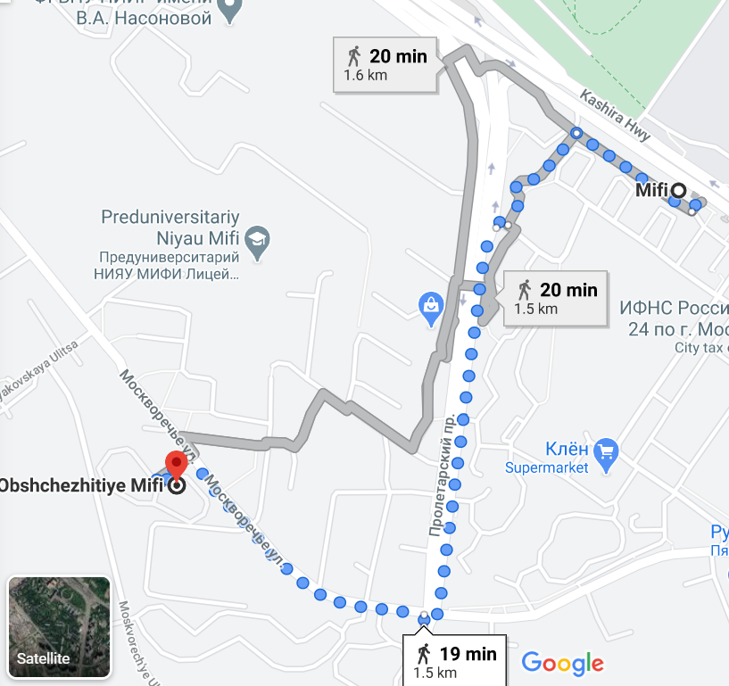
Google maps directions

From Sheremetyevo airport
- Take Aeroexpress train from the airport. Exit at the next stop: Moscow (Belorussikiy Railway Station). Schedule of Aeroexpress is available here.
- Take the Subway (green line). Exit at the station Kashirskaya.
- Walk to the address Moskvorechiye 2 building 1.
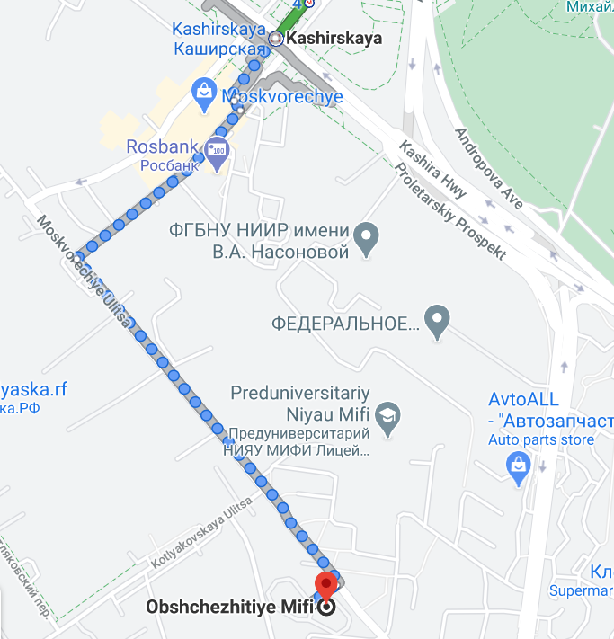
Google maps directions
From Vnukovo airport
- Take Aeroexpress train from the airport. Exit at the next stop: Moscow (Kiyevsky Railway Station). Schedule of Aeroexpress is available here.
- Take the Subway (circle line). Exit at the station Paveletskaya.
- Change lines. Take the green line. Exit at the station Kashirskaya.
- Walk to the address Moskvorechiye 2 building 1.
Google maps directions

